Product & Packaging Materials
Guidelines to import template
WIOS Food ApS

Indhold
Explanation of packaging levels 2
Component 2
Packaging Unit 2
Product 2
Explanation of the "PackagingComponent" tab 2
"ReferenceID" and "Validation" 2
"Name" 2
"Elementcode" 3
"TypeCode" 3
"Weight Value" 3
"Unit of measurement" 3
Explanation of the "PackagingUnit" tab 3
"ReferenceID" and "Validation" 3
"Name" 3
"Type" 4
Explanation of the "ComponentToUnitAssociate" tab 4
"ReferenceID" and "Validation" 4
Explanation of the "Product" tab 4
Explanation of the "ProductAssociate" tab 5
"ReferenceID" and "Validation" 5
Sources of errors 5

Packaging components – WIOS FOOD IMPORT

Explanation of packaging levels
A complete package consists of three levels. The explanation follows here:
Component
A lid, a label, and a carton are all different types of components. The same component can be reused across different packaging units.
Packaging Unit
A collection of components. The same packaging can be used for different product variants.
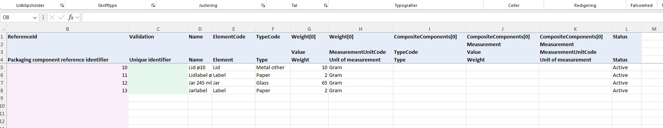
Product
A product with identifiers and product name(s).

Explanation of the "PackagingComponent" tab
Example of a jar with labels on both the lid and the jar.

"ReferenceID" and "Validation"
Use a number between 1-1000 to enter the reference ID. The validation will check if the same number has been used elsewhere in the sheet.
Green means it has only been used once. Red means the number has been used multiple times.
"Name"
Provide a recognizable name for the component. One that can be easily searched later. The name should not contain product-specific information, as the same component can be used for multiple products.
"Elementcode"
Select the type of component. You can use the code "Other" if you cannot find a more appropriate match in the list.
"TypeCode"
Select the material of the component.
"Weight Value"
Enter the weight of the component.
"Unit of measurement"
Select the unit of measurement, for example, grams.
Explanation of the "PackagingUnit" tab
Example of the finished jar, for instance, used for jam.
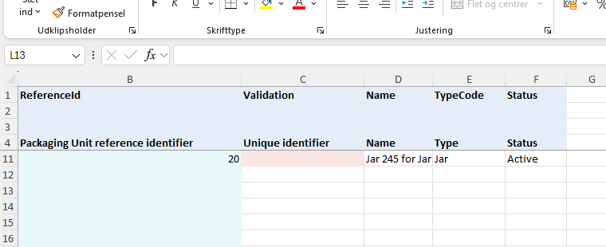

"ReferenceID" and "Validation"
Use a number between 1-1000 to enter the reference ID. The validation will check if the same number has been used elsewhere in the sheet.
Green means it has only been used once. Red means the number has been used multiple times.
"Name"
Provide a recognizable name for the component. One that can be easily searched later. The name should not contain product-specific information, as the same component can be used for multiple products.
"Type"
Select the overall function type for the unit.
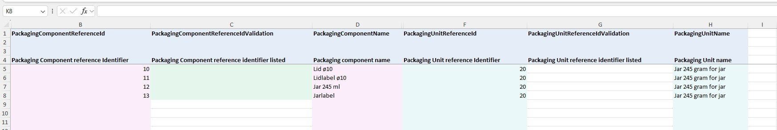
Explanation of the "ComponentToUnitAssociate" tab
Example of an association (a link between) components and packaging components and units.

"ReferenceID" and "Validation"
By using the reference number of the components and units, these can be linked together.
Note how the reference number is used twice, as each line links a component to the same unit.

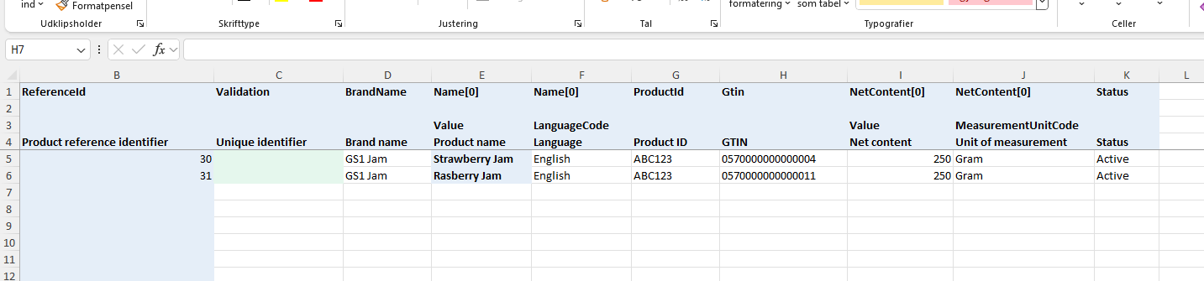
Explanation of the "Product" tab
Example of data for multiple products.

In this tab, you have the opportunity to insert all the products that you wish to create in GS1Trade Packaging. These products can then be linked to the relevant packaging units.

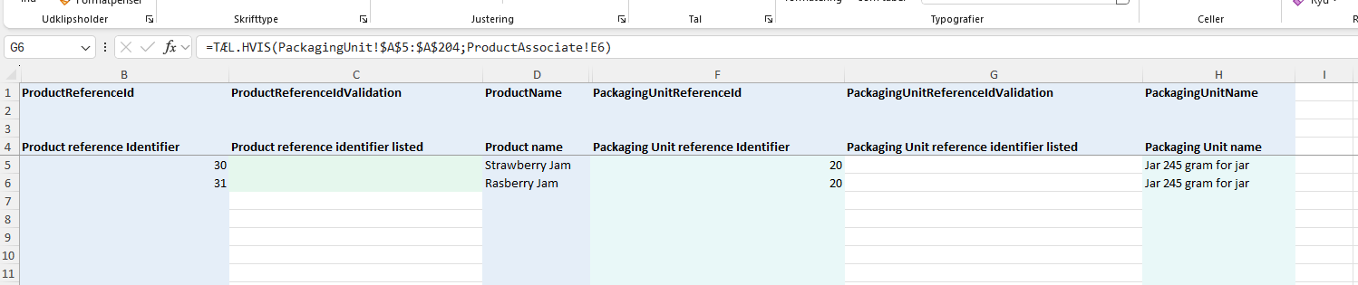
Explanation of the "ProductAssociate" tab
Example of how to link units and products together.

"ReferenceID" and "Validation"
Products can be linked to units using the reference numbers. The numbers assigned to the different units can be inserted in this tab next to the relevant products to link products and packaging together. Note that the same packaging unit can be used for all products that have the same packaging. For example, different flavors of jam, all filled into the same type of jam jar.

Sources of errors
Note that changes should not be made to the structure of the sheet or the code lists in the "Lookup" tab. Any changes will prevent the template from being imported into GS1Trade Packaging.

